Pass Task 18

Robust Rover

Related Learning Outcomes

**ULO1 – Explain the OO Principles**

**ULO2 – Use OO Language and Library**

The task demonstrates the use of C++ object-oriented programming language, as well as introduces the difference on between C# and C++ programming on the matter of memory management.

**ULO3 – Design, Develop and Test using an IDE**

The task demonstrates how to create and run Unit Tests for C++ programs.

**ULO4 – Communicate using UML Diagrams**

**ULO5 – Describe Elements of Good OO Design**

The task demonstrates the problem of memory management in C++ programming, as well as methods to handle it

IDE screenshots:

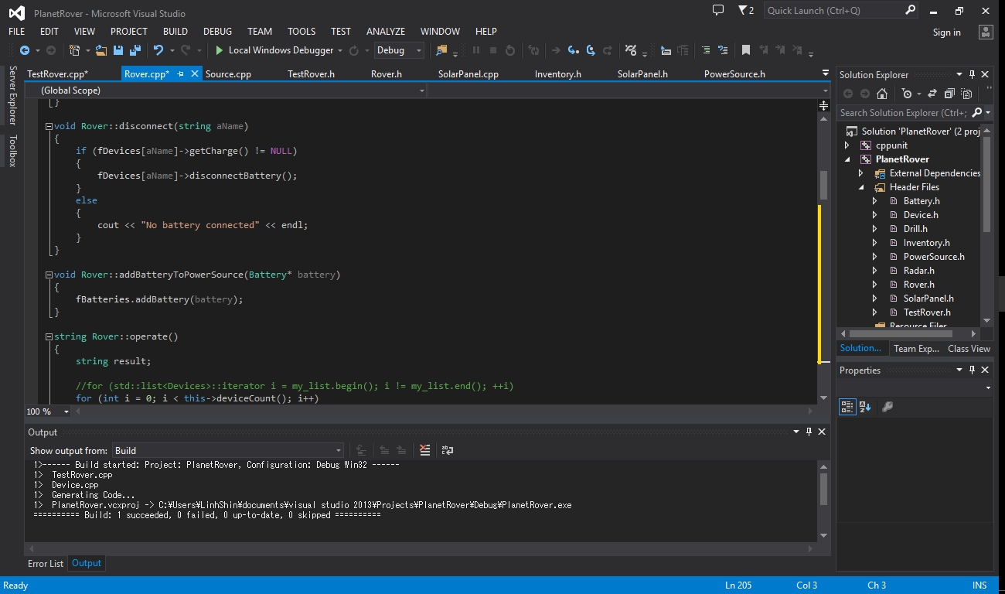

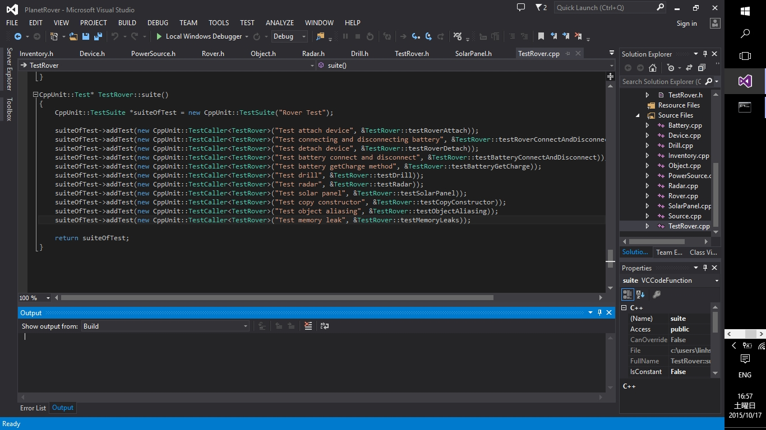

# CPPUNIT testing:

